**Boston University**

**Electrical & Computer Engineering**

**EC463 Senior Design Project**

First Semester Report

Aerobatic BlackBox

Submitted to

Dr. Kenneth D. Sebesta

CyPi Ltd.

Address 1

Address 2

859-648-0272

[kenn@cypiltd.com](mailto:kenn@cypiltd.com)

by

Team 9

Team 9 Aerobatic BlackBox

Team Members

Xinyu Liu xinyubu@bu.edu

Pai Liu paiii@bu.edu

Wenjun Ma wjm123@bu.edu

Radhey K. Patel rexu6@bu.edu

Darcy Meyer darcym@bu.edu

Submitted: Dec 12, 2021

#### Table of Contents

Executive Summary ii

1.0 Introduction 1

2.0 Concept Development 2

3.0 System Description 3

4.0 First Semester Progress 4

5.0 Technical Plan 5

6.0 Budget Estimate 6

7.0 Attachments 7

7.1 Appendix 1 – Engineering Requirements 7

7.2 Appendix 2 – Gantt Chart 8

7.3 Appendix 3 – Other Appendices 9

# Executive Summary

*Aerobatic BlackBox*

*Team 9 – Aerobatic BlackBox*

Aerobatic performances are very different from ordinary flying tasks. General pilots use scientific methods to avoid risks during training, while aerobatic pilots take the initiative to face risks and use their lives to challenge the limits of aircraft performance and flying skills. In the field of aerobatics, there is no limit to the exploration of pilots' flying skills. In different aerobatics, the aircraft's flight status, altitude, speed, direction, and overload parameters change drastically. The pilot must be aware of the flight status at any time, understand the changes in motion parameters, and control the aircraft to move on a predetermined trajectory in a timely and accurate manner. During competition training, ordinary avionics cannot record and replay 3D demonstrations of flight training, and pilots cannot make precise movement adjustments.

In order to help pilots to understand the status of the aircraft, the AHRS came into being, which can help pilots understand the real-time aircraft attitude. However, this system lacks 3D playback of aerobatics, cannot help the pilot to watch the aircraft attitude from the judge's point of view, and cannot record real-time pilot input, which does not meet the needs of aerobatic training.

Our Aerobatic Black Box will address these issues by delivering a hardware part which contains AHRS, INS, GPS and a camera to collect pilot input, and a software part which allows pilot replay 3D demonstration of flight training, and also provides pilot input corresponding to every maneuver. Aerobatic Black Box is specially designed for introductory aerobatics pilots and aerobatics training. This system will allow pilots to observe different angles of flight attitude for the next flight adjustment, and also solves the lack of digital AHRS in some aircraft, maneuver log and greatly reduces the difficulty of aerobatics training.

# Introduction

During aerobatic competition the aircraft's flight status, altitude, speed, direction, and overload parameters change drastically. Pilots must be aware of the flight status at any time, understand the changes in motion parameters, and control the aircraft to move on a predetermined trajectory in a timely and accurate manner. During competition and training, AHRS will help pilots understand the real-time aircraft attitude, however this device cannot record and replay 3 demonstrations of flight training, and pilots cannot make precise movement adjustments based on ordinary avionics.

Under this premise, the client put forward the following requirements to us: First, the equipment must be able to record flight data (including altitude, GPS, and flight attitude). Second, the equipment must be able to record the pilot's input to the aircraft. Third, the equipment must be able to replay 3D flight simulations to help pilots adjust flight movements. Fourth, flight simulation must be able to switch perspectives to help pilots observe aerobatics.

Our Aerobatic Black Box will address client’s issues by providing a hardware part which contains AHRS, INS, and a camera to collect pilot input; the software part which allows pilot replay 3D demonstration of flight maneuvers, and also provides pilot input corresponding to every maneuver. When collecting pilot input, we are faced with the problem that the aircraft does not have a collection interface, so we innovatively use image recognition technology to collect airspeed and pilot input.

The Aerobatic Black Box is specially designed for introductory aerobatics pilots and aerobatics training. This system will allow pilots to observe different angles of flight attitude for the next flight adjustment, and also solves the lack of digital AHRS in some aircraft, and greatly reduces the difficulty of aerobatics training.

# Concept Development

Here you describe your analysis of the customer’s problem and its translation into specific engineering terms. You should address:

* your engineering understanding of the customer’s problem,
* the conceptual approach you have chosen to solve the problem, and

You must reduce the customer’s needs to a small number of engineering requirements. You must identify those requirements as a ***1-page attachment, Appendix 1***

Elaborate on the conceptual approach for your project. Explain briefly why you chose your proposed concept, and mention one or two of the alternative solutions you considered and abandoned.

***(This section should be 2-3 pages)***

***You MUST include a 1 page Requirements list as Appendix 1.***

# System Description

To meet all of the engineering requirements. We design the system as below:

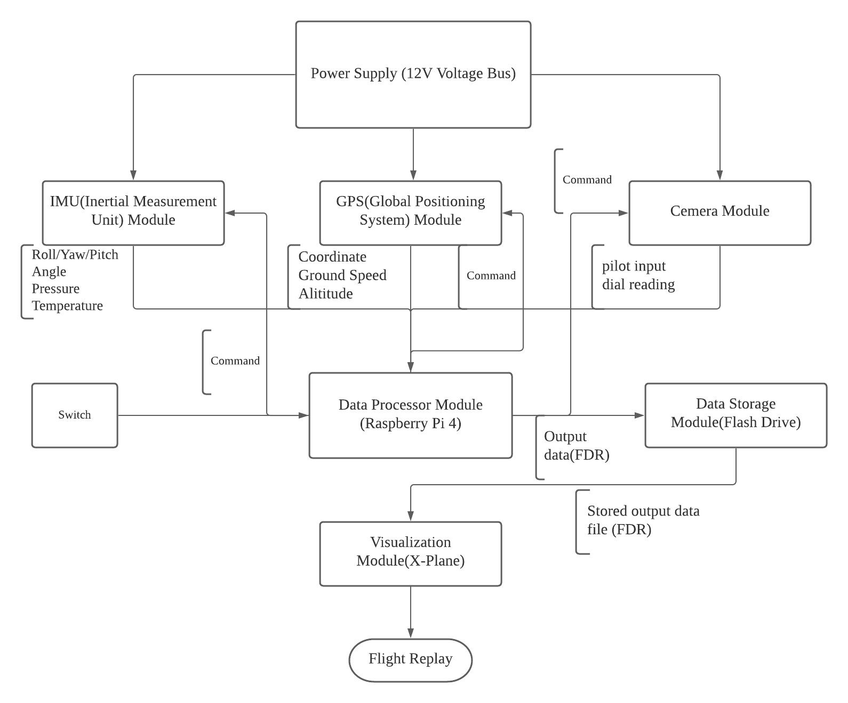

Figure 2. Block diagram of the Aerobatic Black Box

* IMU (Inertial Measurement Unit) Module

BerryGPS-IMU GPS and 10DOF

* GPS (Global Positioning System) Module

BerryGPS-IMU GPS and 10DOF，GPS antenna (AA.162.301111)

* Camera Module

MakerFocus Raspberry Pi4 Camera IR, Raspberry Pi4 Camera Night Vision Fisheye Camera 5mp OV5647

* Data Processor Module

Raspberry Pi4 B

* Data Storage Module

Flash drive

* Visualization Module

Xplane

Our Aerobatic Black Box will address issues by delivering a hardware part which contains AHRS, INS, GPS and a camera to collect pilot input, and a software part which allows pilot replay 3D demonstration of flight training, and also provides pilot input corresponding to every maneuver. The system is functionally consisting of 6 parts. IMU (Inertial Measurement Unit) Module, GPS (Global Positioning System) Module, Camera Module, Data Processor, Data Storage Module and Visualizing Module, which are all supplied by a 12V voltage bus mounted in the aerobatic plane. The IMU module could not only measure the roll,yaw and pitch angle of the plane while the plane is in flight, it also measures the temperature and the pressure surrounding. The GPS module could measure the specific coordinates of the global coordinate system, altitude and calculate the ground speed by processing the coordinates. The camera module, which needs to be mounted in an appropriate place in the aerobatic plane, will record the pilot inputs by measuring the movement of Rudder cables and sense the dial reading from the dashboard on the aerobatic plane. Raspberry Pi 4 B is selected as the data processor of the system since its small size and great capability to work. We would also use a flash drive to save the data which was produced by the Raspberry to be later analyzed for visualization on Xplane.

Once the switch of the system is turned on, the raspberry pi will receive the signal to work and send the command to IMU,GPS and Camera module to start collecting data. The output data will be transmitted back and processed by the raspberry pi. The raspberry pi will save these processed data which will be in fdr format into the flash drive which is needed to be inserted into the system. After the flight is over, the flash drive can be taken out. The data which is stored in the flash drive could be extracted and read by Xplane. Finally, the Xplane will read and analyze the data and generate a whole flight replay which allows pilot replay 3D demonstration of flight training, and also provides pilot input corresponding to every maneuver.

# First Semester Progress

This section is a detailed summary of the progress your team has made this semester. Include key results from your First Deliverable Testing.

# Technical Plan

Describe how you plan to complete your proposed solution.

The performance period of this plan is December 11, 2012 – May 1, 2013. You should not discuss tasks that are already completed or plans that are in the past! Remember the functional testing of your project is the week of April 1 (This is when the project is “due”)

Organize this section as a discussion of tasks and milestones, integrated with your professionally prepared Gantt Chart (Appendix 2)

Tasks should be clearly named. They should be described with a verb-an action word. They should have a clear, measurable deliverable product at their completion.

*Task 2. Battery power supply*

*A 3V, 200 mA battery power supply shall be designed, fabricated and tested. It shall be rechargeable from an external connector and meet specifications for weight, battery life, and heat dissipation. The design should be tested with a dummy load of 900 ohms. Lead: Captain Kirk; Assisting: Scottie.*

***(No more than 4 pages.)***

# Budget Estimate

| **Item** | **Description** | **Cost** |
| --- | --- | --- |
| 1 | BerryGPS-IMU GPS and 10DOF for The Raspberry Pi*2 | $71.20*2 |
| 2 | Raspberry Pi 4 4GB starter kit | $109.95 |
| 3 | GPS antenna (AA.162.301111) | $12.39 |
| 4 | MakerFocus Raspberry Pi4 Camera IR, Raspberry Pi4 Camera Night Vision Fisheye Camera 5mp OV5647 | $34.15 |
| 5 | PRT-12794 female to male wire | $2 |
| 6 | JBtek BMP180 Barometric Pressure, Temperature and Altitude Sensor | $6.99. |
| 7 | IMU 9DOF MPU-9250 | $13.88 |
|  | Total Cost | $321.76 |

The main budget implicant we encountered is that we wasted some budget during the testing time. Our system functionally consists of 3 parts on collecting data: IMU, GPS, and camera modules. Item 6 and 7 are the parts which we first selected and bought for the system IMU part. However, these components need to be soldered to work properly. Then, we chose item1 which includes both the GPS and the IMU module for reducing the required system space and convenience. The reason why we bought two BerryGPS-IMU GPS and 10DOF for The Raspberry is that we accidentally burned one component when we first tried to get some data from the BerryGPS-IMU GPS and 10DOF for The Raspberry Pi.

# Attachments

# Appendix 1 – Engineering Requirements

Team # Team Name:

Project Name:

| **Requirement** | **Value, range, tolerance, units** |
| --- | --- |
| Case dimensions | 2m x 2m x 1.4m |
| Power | 1GJ photon source, and 3V battery |
| Transport range | >100 light years |
| Transport nodes | 3 in simplex mode (no return possible);  2 in duplex mode (round trip stored) |
| Radiation dose | 20 REM/trip +1 REM, -3 REM |
| Transport error rate | < 10-11 molecules of normal body mass  < 10-15 molecules when sending DNA data |

These are your requirements specifications that transform the customer’s needs and wants into specific engineering requirements. See the course textbook regarding the formation of appropriate specifications. Generally these are at the system integration level. Each unit that you design will have its own internal specifications, but these are usually not listed in a proposal.

Specifications should not include vague environmental constraints.

Specifications should not be statements of technology preferences or early design decisions (e.g. “The unit shall use Li ion batteries” is not a specification.)

Not more than one page.

# Appendix 2 – Gantt Chart

Here you provide a STANDARD PRESENTATION OF THE TASKS, MANAGEMENT, AND SCHEDULE of your efforts. You can access MS Project to create a professional Gantt Chart and cut and paste the chart here. (This template was done MS Project and saved to Word. Remember: Clear date headers; dependencies; milestones; hierarchical tasks; course milestones.

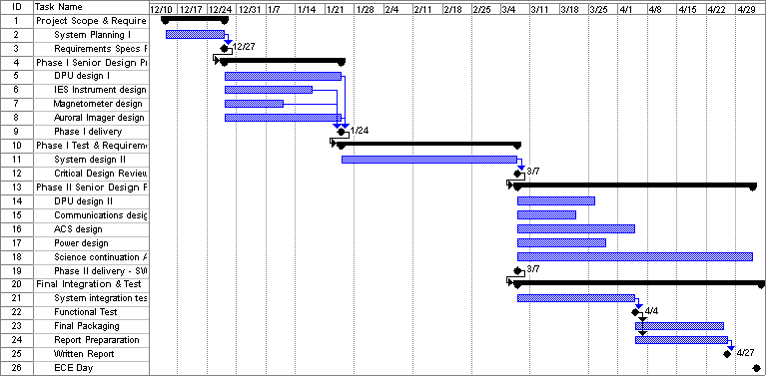

You need not include other MS Project columns like start and end dates, durations, support, etc. Make major milestones clear.

# Appendix 3 – Other Appendices

Other typical attachments that are added to bolster the competitiveness of your proposal:

* Technical references (in proper bibliographic form) including key URLs.
* Your drawings and schematics (rather than embedding in text)
* Team information sheet (Biographical paragraph on each member; phone numbers and e-mail, history of team and company)

Do not pad with mundane data sheets and application notes.

**Spell Check Everything!!!!**

**Paginate and edit footers and headers for your team.**

**Work through at least two drafts before submitting final document.**

**DO NOT bind, put in fancy covers or otherwise embellish. Simply clip with spring binder in upper left corner.**

**Use MS Word or PDF format for final document.**

**Submit one soft copy to course via Blackboard Digital Drop Box, and one copy to customer (include cover letter to customer).**

***The body of the proposal should not exceed 20 pages.***

***(This excludes the cover page, table of contents, executive summary, and attachments.)***